Examen SIM:

* 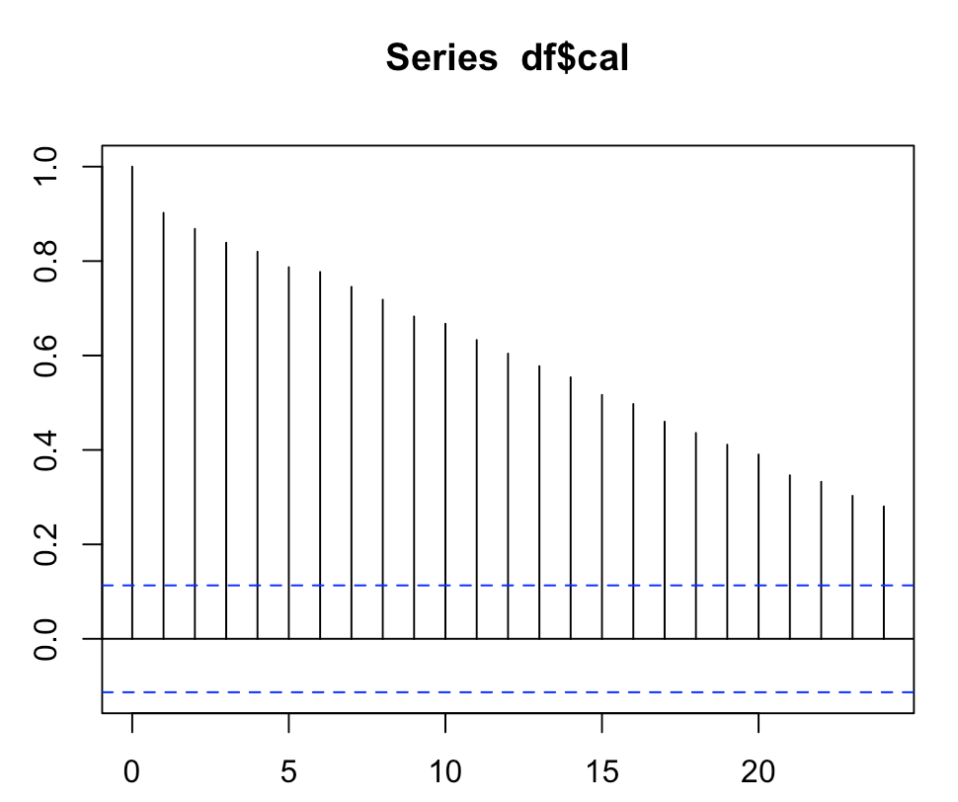

-There is autocorrelation

1. Si tomamos el sodio entonces el total de calorias es mayor a 100gramos entonces no nos sirve. Por eso no lo tomamos, el aim del ejercicio era ver eso.
2. Take numeric variables and find the treshhold for severe outliers.
3. Outliers en fat estan arriba

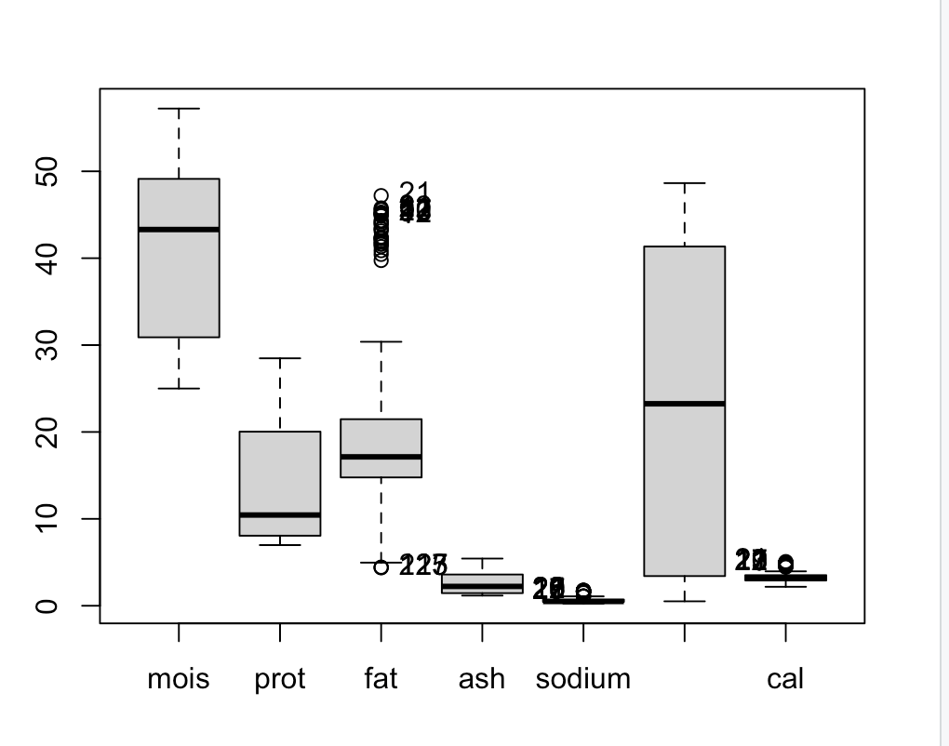

FACTOMINER, CHEMOMETRICS (MEJOR)

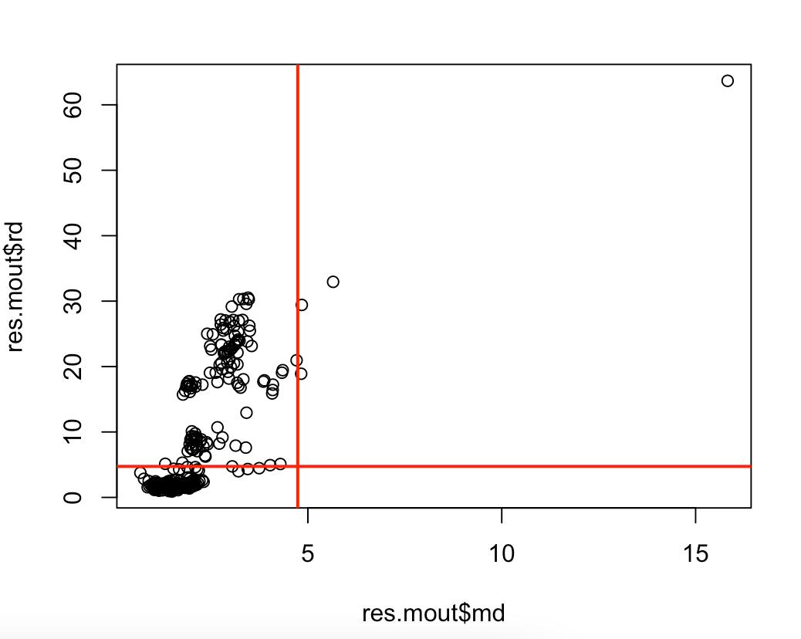

-SELECCIONAMOS LA NUMERICAS

- PRESTAR ATENCION: VARIABLE CON POCOS VALORES, TRATAR DE REMOVERLA PORQUE DA PROBLEMAS

Brand=A has a value mean of 1.5 over the global mean so it has more calories per 100grms

Brand=I …

1. 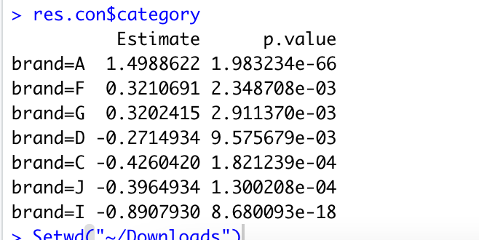
2. Global asociation between numeric variables and the target

All of them very high

A lot of dependencies

Brand = I : water is over the global mean

Sodium, fat and cal: under the global mean

So a lot of water

Brand A=. sodium, fat (American pizza all the fat)

1. Calculate the logarithm for calories. Ks-test especify the mean and standard deviation. The favorite of professor is Shapiro-wilkin

rEJECT THE NORMAL DISTRIBUTION, SO NO GOOD IDEA TO USE LOG NORM DISTRIBUTION